Bangladesh Medical Association (BMA)
List of Life Member-27
05. BMA Bhola Branch

Sl No | Voter No | Voter Details
1 | Voter No  LM-0500001  No Image | DR. NAZRUL ISLAM  F/Name: Abdul Majid Mollah  M/Name:  BM & DC Reg. No:  NID:  Cell:  Address: Resident Medical Officer Borhanuddin UHC Bhola  Blood Group:
2 | Voter No  LM-0500002 | DR. AMALENDU BISWAS  F/Name: Late. Debendra Nath Biswas  M/Name: Late. Soneka Rani Biswas  BM & DC Reg. No: 15416  NID: 0921803163982  Cell: 01716040229  Address: Upazila Health & Family Planning Officer, Lalmohan, Bhola  Blood Group: B+
3 | Voter No  LM-0500003  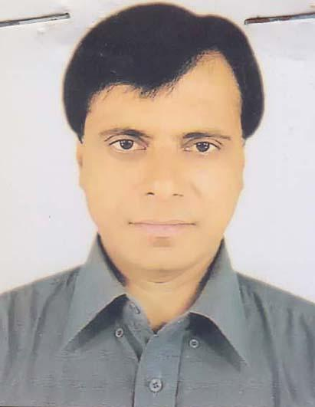 | DR. SANTOSH KUMAR SARKER  F/Name: Bijoy Prosad Sarker  M/Name: Jamuna Rani Sarker  BM & DC Reg. No: 15690  NID: 0925406588370  Cell: 01715018442  Address: Upazilla Health Complex, Lalmohon, Bhola  Blood Group: O+
4 | Voter No  LM-0500004  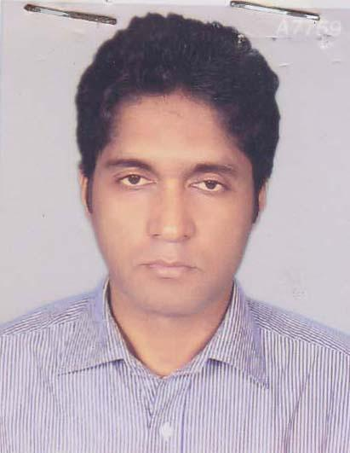 | DR. BINOY KRISHNA GOLDER  F/Name: Neriod Chandra Golder  M/Name: Suchitra Rani Mondal  BM & DC Reg. No: 29394  NID: 695112194066  Cell: 01712247616  Address: Junior Consultant-Gynae, Upazilla Health Complex, Lalmohan, Bhola  Blood Group: A+
5 | Voter No  LM-0500005 | DR. MAHMUDUR RASHID  F/Name: Late. Md. Sherazul Haque  M/Name: Mazeda Begum  BM & DC Reg. No: 24818  NID: 0925406588311  Cell: 01711407392  Address: Upazilla Health Complex, Lalmohon Bhola  Blood Group: O+
6 | Voter No  LM-0500006  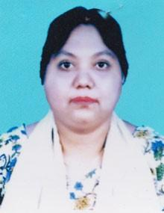 | DR. SURAIYA YASNOOR  F/Name: Md. Maksud Chowdhury  M/Name: Parul Begum  BM & DC Reg. No: 23770  NID: 4795131562730  Cell: 01712172334  Address: Consultant Gynae, Sadar Hospital, Bhola  Blood Group: A+
7 | Voter No  LM-0500007 | DR. FARID AHMED  F/Name: Late. Dr. Sultan Ahmed  M/Name: Late. Fatema Begum  BM & DC Reg. No: 13625  NID: 0921803161796  Cell: 01715110026  Address: Upazilla Health & Family Planning Office, Sadar Upazila Health Complex, Bhola  Blood Group: B+
8 | Voter No  LM-0500008 | DR. MD. ABDUL KADIR  F/Name: Md. Abdul Awal  M/Name: Rokeya Begum  BM & DC Reg. No: 27546  NID: 0921807141438  Cell: 01714396629  Address: Consultant Pediatric, Sadar Hospital, Bhola  Blood Group: AB+
9 | Voter No  LM-0500009 | DR.AFM RAFIQUL HASAN  F/Name: Md. Nur Ali  M/Name: Mrs. Rashida Khatun  BM & DC Reg. No: 13438  NID: 8714779245953  Cell: 01740899499  Address: UH & FPO UHC, Monpura, Bhola  Blood Group: B+
10 | Voter No  LM-0500010  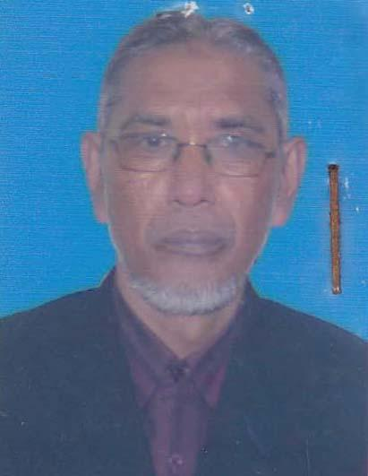 | DR. MD. MOSLEH UDDIN  F/Name: Motahar Uddin Ahmad  M/Name: Noorjahan Begum  BM & DC Reg. No: 13746  NID: 922106080065  Cell: 01768169877  Address: Upazilla Health Complex, Tajumuddin, Bhola  Blood Group: AB+
11 | Voter No  LM-0500011 | DR. MD. SIDDIQUR RAHMAN  F/Name: Late. Abul Hashem Mia  M/Name: Monowara Begum  BM & DC Reg. No: 15744  NID: 0922505720529  Cell: 01714051117  Address: Doctors Quarter, Charphashion, Bhola  Blood Group: O+
12 | Voter No  LM-0500012 | DR. MD. ZAHURUL ISLAM  F/Name: Late. Khorshed Alam  M/Name: Late. Salma Begum  BM & DC Reg. No: 36517  NID: 0912157224108  Cell: 01712569372  Address: UHC, Borhanuddin, Bhola  Blood Group: A+
13 | Voter No  LM-0500013  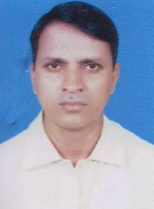 | DR. MD. MASUM  F/Name: Mahbub-ul-alam  M/Name: Momtaz Begum  BM & DC Reg. No: 22031  NID: 0695102110129  Cell: 01716042961  Address: Upazilla Health Complex, Borhanuddin, Bhola  Blood Group: A+
14 | Voter No  LM-0500014  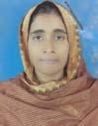 | DR. NASIMA KHANAM  F/Name: Anwar-ul-haque  M/Name: Farida Khatun  BM & DC Reg. No: 34453  NID: 0921803161582  Cell:  Address:  Blood Group: AB+
15 | Voter No  LM-0500015  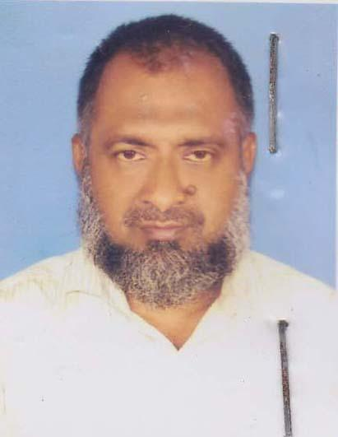 | DR.MD. SHAH ALAM  F/Name: Late Md. Nurul Islam  M/Name: Late. Jahanara Khatun  BM & DC Reg. No: 11894  NID:  Cell: 01716586734  Address: UHFPO DAULATKHAN BHOLA  Blood Group: B+
16 | Voter No  LM-0500016 | DR. SHAHARIER YASIN  F/Name: Mahammad Yasin  M/Name: Selina Banu  BM & DC Reg. No: 56842  NID: 2696352208824  Cell: 01761720963  Address: Borhanuddin UHC, Bhola Hospital Quarter  Blood Group: O+
17 | Voter No  LM-0500017 | DR.MUIN UDDIN TALUKDER  F/Name: Saleh Uddin Talukder  M/Name: Yeanur Begum  BM & DC Reg. No: 60491  NID: 2627205549483  Cell: 01717285677  Address: UHC, Borhanuddin, Bhola  Blood Group: O+
18 | Voter No  LM-0500018 | DR. MD. SHAFIQUL ISLAM DEWAN  F/Name: Noor Mohammad Dewan  M/Name: Shahida Begum  BM & DC Reg. No: 63752  NID: 9196201102525  Cell: 01719443415  Address: Doctors Quarter, Upazilla Health Complex, Borhanuddin, Bhola  Blood Group: O+
19 | Voter No  LM-0500019 | DR. TISHADURE RAHMAN  F/Name: Motiur Rahman  M/Name: Bithi Rahman  BM & DC Reg. No: 59819  NID: 2694814952161  Cell: 01722522650  Address: Doctor's Quarter, Borhanuddin Upazilla Health Complex, Borhanuddin, Bhola  Blood Group: B+
20 | Voter No  LM-0500020 | DR. MD. SHAHIDULLAH  F/Name: Md. Ibrahim Khalil Farazi  M/Name: Jahanara Begum  BM & DC Reg. No: 62132  NID: 19890695111185338  Cell: 01913955305  Address: Doctors Quarter, Upazilla Health Complex, Borhanuddin, Bhola  Blood Group: B+
21 | Voter No  LM-0500021  No Image | ***NIL***  F/Name:  M/Name:  BM & DC Reg. No:  NID:  Cell:  Address:  Blood Group:
22 | Voter No  LM-0500022  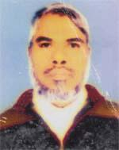 | DR. MOHAMMAD MOHIBULLAH  F/Name: Late. Moulavi Tofazzal Hossain  M/Name: Late. Mahamuda Begum  BM & DC Reg. No: 15654  NID: 19620421809149487  Cell: 01712526049  Address: Poura Charjongla, Ward No-9, Bhola Pouroshova, Dist-Bhola  Blood Group: A+
23 | Voter No  LM-0500023 | DR. MOHAMMED OBAYEDUR RAHMAN  F/Name: Abdul Awwal  M/Name: Rokeya Begum  BM & DC Reg. No: 35589  NID: 2697557395595  Cell: 01922005086  Address: House-38, Road 05, Pisciculture Housing, Mohammadpur, Dhaka  Blood Group: B+
24 | Voter No  LM-0500024 | DR. MD. ALAUDDIN  F/Name: Late. Abdur Rahman Talukdar  M/Name: Late. Arifa Khatun  BM & DC Reg. No: 9691  NID: 0921807141713  Cell: 01716003357  Address: Musalman Para, Nur Maszid Road, Pouroshova: Bhola, Dist: Bhola  Blood Group: A+
25 | Voter No  LM-0500025  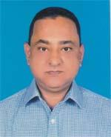 | DR. HIMADRI SHEKHAR GHOSAL  F/Name: Sukharanjan Ghosal  M/Name: Namita Sarkhel  BM & DC Reg. No: 20679  NID: 0921806458323  Cell: 01715182736  Address: Bhola diagnostic centre, Panch Tarabil Road, Bhola Sadar, Bhola  Blood Group: O+
26 | Voter No  LM-0500026  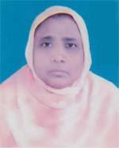 | DR. PARVIN BEGUM  F/Name: Ali Asgar Hawlader  M/Name: Sahera Khatun  BM & DC Reg. No: 19962  NID: 0911814335874  Cell: 01714536761  Address: Alif Medical Services, Alam Villa, Sadar Road, Bhola  Blood Group: B+
27 | Voter No  LM-0500027  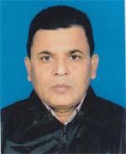 | DR. ABU BAKAR SIDDIQUE BABUL  F/Name: Md. Hanif Mia  M/Name: Mrs. Mahfuza Khatun  BM & DC Reg. No: 590  NID: 0911814335873  Cell: 01712009432  Address: Alif Medical Services, Alam Villa, Sadar Road, Bhola  Blood Group: B+

